Infrared obstacle avoidance sensor

Overview：
This project will test Infrared obstacle avoidance sensor. When an obstacle is blocks infrared sensor, it will turn on LED in the circuit.

Materials：
Arduino Uno x 1
Infrared obstacle sensor module x 1
DuPont wires x 3

Product description :

The infrared obstacle avoidance sensor is a kind of adjustable obstacle avoidance sensor designed for wheeled robots. This sensor light is adaptable to the environment and high precision. It has a pair of infrared transmitting and receiving tube. The tube emits a certain frequency of infrared light. When the detection direction meets an obstacle (reflecting surface), the infrared reflection is received by the receiving tube. At this time, the indicator light is on. After the circuit processing, the signal output interface output digital signal and the detection distance can be adjusted by the potentiometer knob. The effective distance is 2 ~ 40cm and the working voltage is 3.3V-5V. Due to the wide range of operating voltage, it can work stably under the condition that the power supply voltage fluctuates greatly. It is suitable for various single chip microcomputer, Arduino controller, BS2 controller, and can be installed on the robot to detect the changes of the surrounding environment.

Technical Parameters ：
◆Working Voltage: DC 3.3 v-5v
◆Working Current: ≥ 20mA.
◆Working Temperature: - 10 ℃ to + 50 ℃
◆Detection Distance: 2 ~ 40 cm
◆IO Interface: 4 Wire Interface (-/+/S/EN)
◆Output Signal: TTL level (low level with obstruction, high level without obstruction)
◆Adjust Way: Multi - coil Resistance Adjustment
◆ Effective Angle: 35 °
◆Size: 45mm x 18mm
◆205 Resistance: Adjust Distance.
◆103 Resistance: Adjust the Frequency

Wiring diagram:
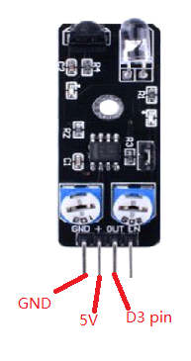
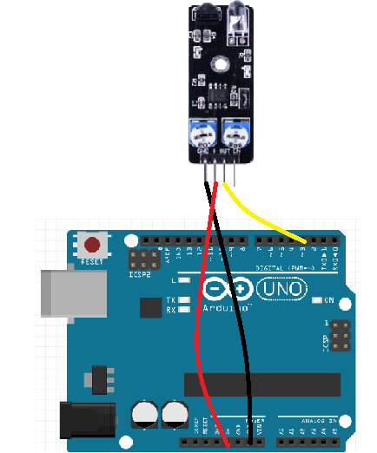

Example code:
/* Infrared obstacle sensor module test project
*/
int Led=13;
int buttonpin=3;
int val;
void setup()
{
pinMode(Led,OUTPUT);
pinMode(buttonpin,INPUT);

}
void loop()
{
val=digitalRead(buttonpin);
if(val==LOW)
{
digitalWrite(Led,HIGH);
}
else
{
digitalWrite(Led,LOW);
}

}

Experimental phenomena：
When the infrared obstacle avoidance module detects the obstacle, the LED light is on. When the obstacle is out of the detection range, the LED light is off.

